Supplementary Table S1 Generalized estimating equation analysis of temporal trends in inflammatory, immune-metabolic, and vascular markers
Variables | β | SE | 95% CI | p-value
Hemoglobin
Intercept | 13.62 | 0.26 | 13.11, 14.13 | <0.001
CCRT vs. OP | −0.80 | 0.51 | −1.80, 0.19 | 0.112
CCRT + UFUR vs. OP | −0.95 | 0.51 | −2.09, 0.08 | 0.063
Week 2 | −0.60 | 0.18 | −0.95, −0.25 | <0.001
Week 12 | −0.30 | 0.24 | −0.77, 0.17 | 0.211
Week 24 | 0.10 | 0.22 | −0.33, 0.53 | 0.648
CCRT × Week 2 | −0.09 | 0.27 | −0.62, 0.44 | 0.738
CCRT × Week 12 | −1.95 | 0.35 | −2.64, −1.26 | <0.001
CCRT × Week 24 | −0.55 | 0.32 | −1.18, 0.08 | 0.087
CCRT + UFUR × Week 2 | −0.09 | 0.29 | −0.66, 0.48 | 0.756
CCRT + UFUR × Week 12 | −1.85 | 0.37 | −2.57, −1.13 | <0.001
CCRT + UFUR × Week 24 | −0.52 | 0.35 | −1.12, 0.17 | 0.139
NLR
Intercept | 3.70 | 0.50 | 2.72, 4.68 | <0.001
CCRT vs. OP | 0.40 | 0.63 | −0.83, 1.63 | 0.526
CCRT + UFUR vs. OP | 0.25 | 0.67 | −1.06, 1.56 | 0.709
Week 2 | 1.85 | 0.38 | 1.11, 2.59 | <0.001
Week 12 | 0.45 | 0.45 | −0.43, 1.33 | 0.318
Week 24 | 0.15 | 0.48 | −0.79, 1.09 | 0.754
CCRT × Week 2 | 1.20 | 0.55 | 0.12, 2.28 | 0.029
CCRT × Week 12 | 4.90 | 1.32 | 2.31, 7.49 | <0.001
CCRT × Week 24 | 0.40 | 1.42 | −2.38, 3.18 | 0.778
CCRT + UFUR × Week 2 | 1.35 | 0.58 | 0.21, 2.49 | 0.020
CCRT + UFUR × Week 12 | 4.85 | 1.38 | 2.14, 7.56 | <0.001
CCRT + UFUR × Week 24 | 0.50 | 1.58 | −2.60, 3.60 | 0.752
SII
Intercept | 1005.0 | 244.0 | 527.0, 1483.0 | <0.001
CCRT vs. OP | −150.0 | 256.0 | −652.0, 352.0 | 0.558
CCRT + UFUR vs. OP | −215.0 | 251.0 | −707.0, 277.0 | 0.392
Week 2 | 485.0 | 165.0 | 161.6, 808.4 | 0.003
Supplementary Table S1 (Continued).
Variables | β | SE | 95% CI | p-value
Week 12 | 80.0 | 180.0 | −272.8, 432.8 | 0.657
Week 24 | 120.0 | 191.0 | −254.3, 494.3 | 0.530
CCRT × Week 2 | 320.0 | 245.0 | −160.2, 800.2 | 0.192
CCRT × Week 12 | 890.0 | 278.0 | 149.4, 1630.6 | 0.019
CCRT × Week 24 | 100.0 | 346.0 | −774.1, 974.1 | 0.823
CCRT + UFUR × Week 2 | 375.0 | 258.0 | −130.8, 880.8 | 0.146
CCRT + UFUR × Week 12 | 980.0 | 291.0 | 213.6, 1746.4 | 0.012
CCRT + UFUR × Week 24 | 90.0 | 346.0 | −820.6, 990.6 | 0.854
PNI
Intercept | 40.60 | 0.66 | 39.31, 41.89 | <0.001
CCRT vs. OP | −1.20 | 0.93 | −3.02, 0.62 | 0.197
CCRT + UFUR vs. OP | −1.10 | 1.02 | −3.10, 0.90 | 0.281
Week 2 | −2.15 | 0.45 | −3.03, −1.27 | <0.001
Week 12 | −4.30 | 0.60 | −5.47, −3.13 | <0.001
Week 24 | −0.80 | 0.56 | −1.90, 0.30 | 0.154
CCRT × Week 2 | −0.35 | 0.68 | −1.68, 0.98 | 0.607
CCRT × Week 12 | 0.70 | 0.86 | −0.98, 2.38 | 0.415
CCRT × Week 24 | 0.25 | 0.94 | −1.59, 2.09 | 0.790
CCRT + UFUR × Week 2 | −0.45 | 0.72 | −1.86, 0.96 | 0.532
CCRT + UFUR × Week 12 | 0.40 | 0.93 | −1.42, 2.22 | 0.668
CCRT + UFUR × Week 24 | 0.30 | 1.04 | −1.74, 2.34 | 0.773
ASI
Intercept | 71.50 | 4.80 | 62.09, 80.91 | <0.001
CCRT vs. OP | −1.70 | 6.88 | −15.19, 11.79 | 0.805
CCRT + UFUR vs. OP | −3.10 | 6.81 | −16.45, 10.25 | 0.649
Week 2 | 0.50 | 1.88 | −3.18, 4.18 | 0.790
Week 12 | −1.30 | 2.12 | −5.45, 2.85 | 0.540
Week 24 | −1.70 | 2.22 | −6.05, 2.65 | 0.444
CCRT × Week 2 | 2.65 | 3.35 | −3.91, 9.21 | 0.429
CCRT × Week 12 | 10.45 | 4.28 | 2.06, 18.84 | 0.015
CCRT × Week 24 | 1.85 | 4.68 | −7.32, 11.02 | 0.693
CCRT + UFUR × Week 2 | 2.95 | 3.48 | −3.87, 9.77 | 0.397
Supplementary Table S1 (Continued).
Variables | β | SE | 95% CI | p-value
CCRT + UFUR × Week 12 | 11.80 | 4.42 | 3.13, 20.47 | 0.008
CCRT + UFUR × Week 24 | 2.20 | 4.88 | −7.36, 11.76 | 0.652
baPWV
Intercept | 15.45 | 0.63 | 14.22, 16.68 | <0.001
CCRT vs. OP | −0.25 | 0.93 | −2.07, 1.57 | 0.788
CCRT + UFUR vs. OP | 0.20 | 0.96 | −1.68, 2.08 | 0.835
Week 2 | 0.10 | 0.35 | −0.59, 0.79 | 0.775
Week 12 | 0.05 | 0.40 | −0.73, 0.83 | 0.900
Week 24 | 0.10 | 0.43 | −0.74, 0.94 | 0.816
CCRT × Week 2 | 0.55 | 0.60 | −0.63, 1.73 | 0.361
CCRT × Week 12 | 2.00 | 0.88 | 0.28, 3.72 | 0.015
CCRT × Week 24 | 0.45 | 0.95 | −1.41, 2.31 | 0.636
CCRT + UFUR × Week 2 | 0.65 | 0.64 | −0.60, 1.90 | 0.310
CCRT + UFUR × Week 12 | 2.20 | 0.92 | 0.40, 4.00 | 0.008
CCRT + UFUR × Week 24 | 0.55 | 1.02 | −1.45, 2.55 | 0.590
Notes: Reference categories were the surgery-alone group and baseline (week 0). Interaction terms represent differential changes over time. Models were adjusted for clinical stage (III–IV vs I–II).
Abbreviations: ASI, Arterial stiffness index; baPWV, Brachial–ankle pulse wave velocity; CCRT, Concurrent chemoradiotherapy; CI, Confidence interval; NLR, Neutrophil-to-lymphocyte ratio; PNI, Prognostic nutritional index; SE, Standard error; SII, Systemic immune-inflammation index.

Supplementary Table S2 Postoperative complications and grade ≥3 CCRT-related toxicities
 | OP  (n = 60) | OP + CCRT  (n = 40) | OP + CCRT +  UFUR (n = 40)
OP complications (n, %)
Infections | 12 (20.0) | 10 (25.0) | 12 (30.0)
Reoperation | 7 (11.7) | 9 (22.5) | 11 (27.5)
Clavien–Dindo ≥ III | 11 (18.3) | 12 (30.0) | 13 (32.5)
CCRT-related toxicities (Grade ≥ 3) (n, %)
Anemia | N/A | 6 (15.0) | 6 (15.0)
Leukopenia | N/A | 7 (17.5) | 8 (20.0)
Febrile neutropenia | N/A | 5 (12.5) | 6 (15.0)
Mucositis | N/A | 25 (62.5) | 28 (70.0)
Dysphagia | N/A | 10 (25.0) | 12 (30.0)
Thrombotic events (n, %) | 0 (0) | 0 (0) | 0 (0)
Abbreviations: CCRT, Concurrent chemoradiotherapy; N/A, Not applicable; OP, Operation.
Supplementary Table S3 Receiver operating characteristic analysis of inflammatory, immune-metabolic, and metabolic biomarkers predicting postoperative complications and concurrent chemoradiotherapy-related toxicities
Outcome | Parameter | AUC | Sensitivity  (%) | Specificity  (%) | Cutoff Value
Surgery-related complications
Infection | NLR | 0.707 | 90.0 | 54.4 | 3.5
Infection | PNI | 0.631 | 76.7 | 50.0 | 40.2
Clavien–Dindo ≥ III | PNI | 0.640 | 90.8 | 59.8 | 40.5
Reoperation | PNI | 0.651 | 83.3 | 42.5 | 41.4
CCRT-related toxicities
Febrile neutropenia | NLR | 0.688 | 63.6 | 72.4 | 3.1
Febrile neutropenia | Uric acid | 0.695 | 81.8 | 57.5 | 5.5
Mucositis (Grade ≥ 3) | SII | 0.660 | 81.6 | 50.0 | 1100.0
 | Uric acid | 0.709 | 71.1 | 63.6 | 5.3
Notes: Cutoff value represents the threshold that maximizes the sum of sensitivity and specificity (Youden index).
Abbreviations: AUC, Area under the receiver operating characteristic curve; CCRT, Concurrent chemoradiotherapy; NLR, Neutrophil-to-lymphocyte ratio; PNI, Prognostic nutritional index; SII, Systemic Immune-Inflammation Index.

Supplementary Figure S1. Receiver operating characteristic curves of
biomarkers for predicting treatment-related severe complications.
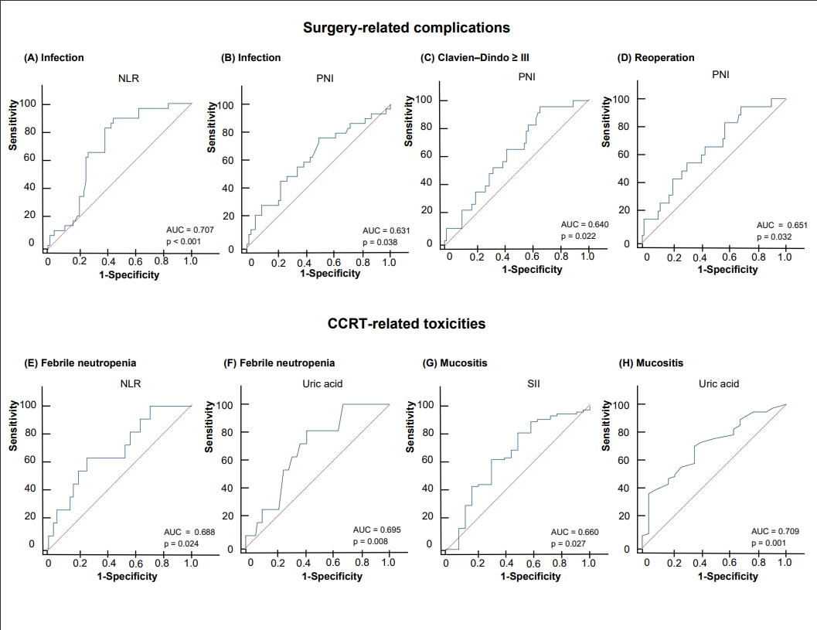
Notes: Surgery-related complications: (A) NLR for postoperative infection; (B) PNI for postoperative infection; (C) PNI for Clavien–Dindo ≥ III; (D) PNI for reoperation.
CCRT-related toxicities: (E) NLR for febrile neutropenia; (F) Serum uric acid for febrile neutropenia; (G) SII for grade ≥ 3 mucositis; (H) Serum uric acid for grade ≥ 3 mucositis.
Abbreviations: AUC, area under the receiver operating characteristic curve;
CCRT, concurrent chemoradiotherapy; NLR, neutrophil-to-lymphocyte ratio;
PNI, prognostic nutritional index; SII, systemic immune-inflammation index.

